Anonymous Patriots
THE PLAN

The Problem
The federal and many state governments are out of control. We the People have become the enemy of our government. We have stood by too long watching the CONTRACT between We the People and the government, the United States Constitution, be ripped to shreds. We just watched a coup d’etat in Congress as representatives who should be protecting the Constitution are waving foreign flags in Congress after the treasonous vote to give the government LEGAL authority to spy on Americans without a warrant.
The House of Representatives passed the bill that reauthorizes Section 702 of the Foreign Intelligence Surveillance Act for two years, expanding the federal government's power to spy on Americans without a warrant.
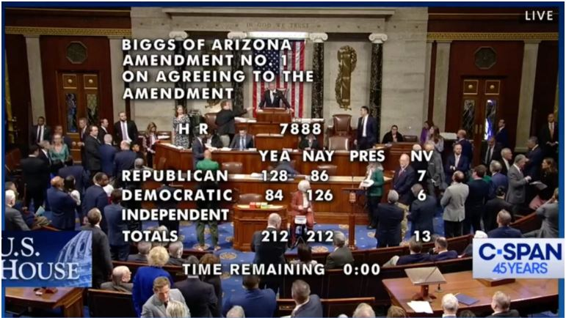
The Senate voted 60-34 to renew Section 702 of the Foreign Intelligence Surveillance Act, where it now heads to Biden for final passage. Read more.
“By expanding the government’s surveillance powers without adding a warrant requirement that would protect Americans, the House has voted to allow the intelligence agencies to violate the civil rights and liberties of Americans for years to come.” Read more.

The Fourth Amendment requires the government to go to court and obtain a warrant if it has reason to spy on a citizen. Not anymore! We are back to GROUND ZERO when the British Monarchy ruled us until we left to start America.

The Solution
We have no choice but to ACT. It is upon the citizens of the United States to get its government under control and back to the original contract. The plan is to begin rounding up the traitors and giving them treason and/or sedition trials at the county level. We will do this through the protection of the county Sheriff’s Office.
Many people are not aware that the county sheriff’s office system protects citizens from state and federal overreach and unconstitutional rules, regs, and laws. There are 3,143 counties in America. We will not need every county to implement this plan; just a handful will send waves of terror through the House and Senate.
Think of the county system like a SAFETY NET for the country. These individual counties make up our country. Each county (or parish) has a sheriff’s office. See the safety netting in this image?

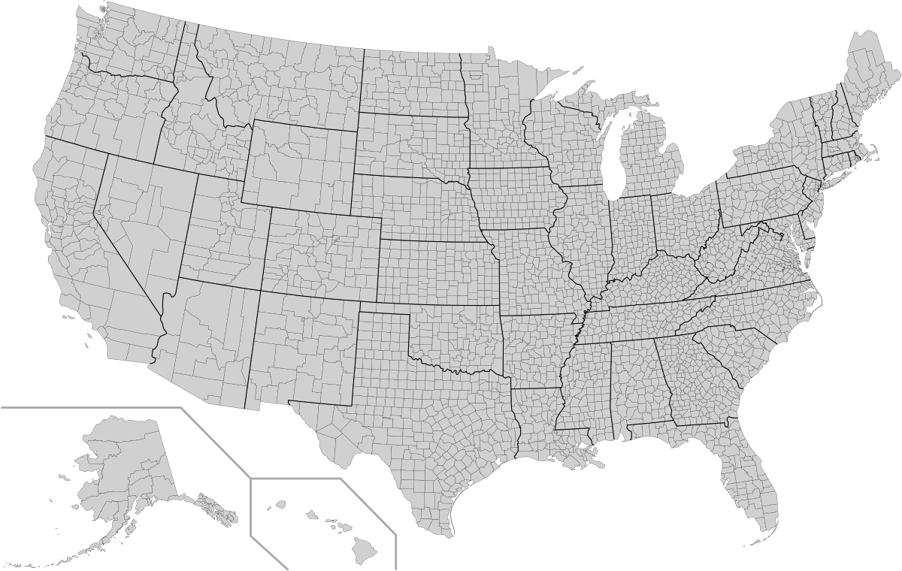
A citizen can report TREASON or sedition officially to their county Sheriff Office. Find the location of the main office of your Sheriff and physically go down and register an official report.



Let’s use Rep. Mike Johnson as an example- the Speaker of the House - who cast the deciding 212-212 vote on Section 702 FISA. Speaker Johnson comes from a district in Louisiana.

If you live in a parish (county) in Johnson’s district, please go to your county sheriff’s office and file a treason report on Mike. It takes 2 witnesses, but the more, the merrier.
Let’s start with Mike who cast the deciding vote. After him, We the People can start charging treason and/or sedition with their county sheriff on other treasonous (s)elected representatives.

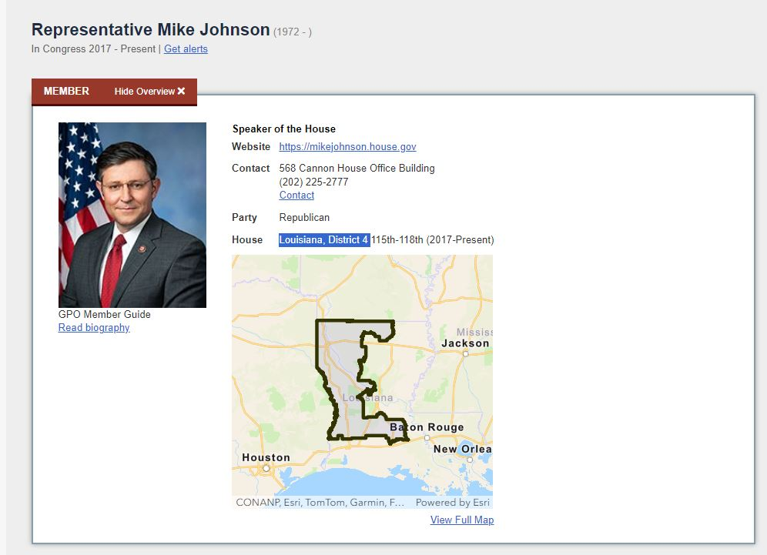

Speaker Mike Johnson and everyone in the HOUSE and SENATE who voted yea on this bill gave us public proof of their treason. An official vote was taken and registered by name.
The vote in the House.
The vote in the Senate.
We need brave men and women to walk into their county SHERIFF OFFICE and file a charges on their elected representatives - House and/or Senate members – who were supposed to uphold the oath of office
Instead, our FOURTH AMENDMENT rights were thrown to the wolves.

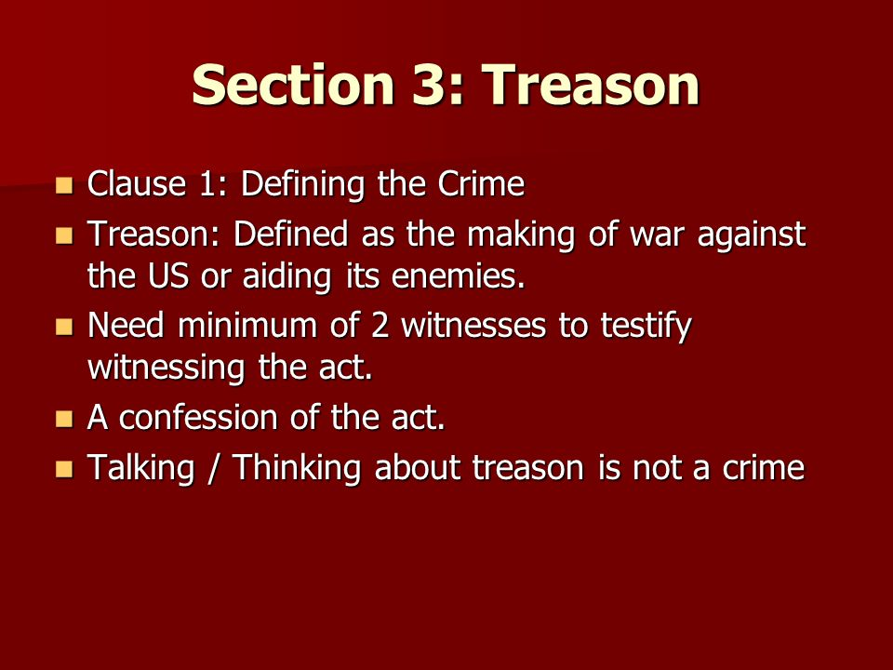

And, yes, we are still in times of war. Just because the enemy is within Congress (crown agents, saboteurs, and dual citizens) and has not officially declared war on the American people doesn’t absolve them from treason or sedition. The American Revolution was not won the way our fake history books tell us. This was public school indoctrination. We are still at war with the British who are annexing America back into the monarchy.
TIME TO FINISH THE AMERICAN REVOLUTIONARY WAR!
The Sheriff Office (SO) is the citizen safety net for out-of-control federal and state governments. SOs are created by state constitutions and for the most part) are elected by voters in the county. The SO answers directly to the people and is not under the control of the state governors or legislators.
The SO is not beholden to unconstitutional federal and state laws and is in place to protect the citizens in its county.
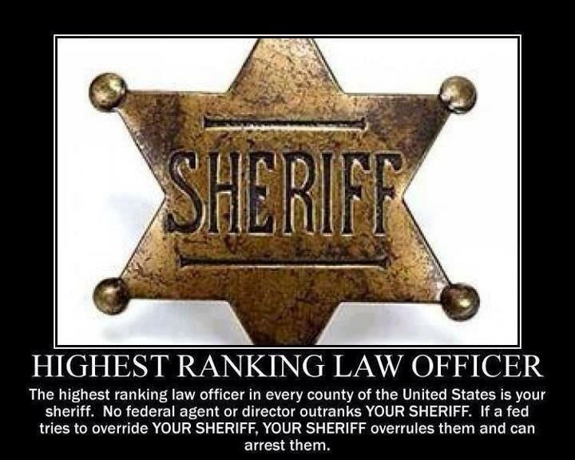
Did you know that the SO can raise a county militia in the form of volunteer and paid deputies? This will be important as we will need to capture the foreign invaders that congressional traitors released in our country.
How will we coordinate our efforts? Sheriffs and deputies take oaths to support and defend the Constitution of the United States against all enemies, foreign and domestic. We the People agreed on this contract for the operation of our government. The feds were never to have the central, dictatorial system we see in place now. We have an obligation to one another to FOLLOW THE TERMS OF THE CONTRACT exactly as written.

The Second Amendment exists to protect citizens from traitors and invaders.


We won’t need every county to do this for the plan to work. Once the House representatives and Senators see a few colleagues being detained in a county jail on the charges of treason, with a speedy trial date set in a county court and the gallows being built on the courthouse grounds, the entire Congress will be too fearful to ever go back to their districts.
It’s time for guillotines. Right on the lawns of over 3,000 county courthouses.

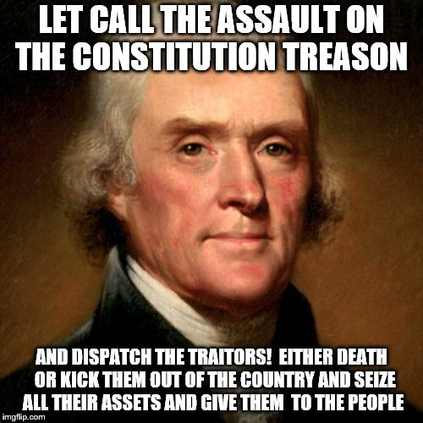

If you are receiving this information, you are a front-line ‘soldier’ in the Great Information War. You can influence the people in your network to take up the plan. Pass these instructions to all you know. Share Operation: Deputy Dawg by distributing this PDF in whatever form of communication is best to reach the peeps in your downline.


If you are not an American, please distribute this information as you may have people in your network who live in the U.S. Plus, others might be inspired to find similar local solutions to the traitors in their countries.
Key message #1: Get involved with your county sheriff’s office.
Know who your sheriff is and when they are elected or appointed. Subscribe to their newsletters and follow their social media platforms. Volunteer as appropriate. Join your county militia through the SO. Elect constitutional sheriffs and throw the George Soros puppets out of office.
Key message #2: Arrest the traitors from Congress who reside and/or represent your county.
Give them a public trial in a county court. Execute them in a public manner; volunteer to build gallows and guillotines on the courthouse grounds.
Do that a few times around the country and watch the swamp roaches, rats, and snakes scurry out of your district to find safe places to live out the rest of their miserable lives.



